

Kudlu Gate, Hosur Road, Bengaluru – 560068

SCHOOL OF COMPUTER APPLICATIONS

A Project Report
on

AI BASED TRAVEL RECOMMENDATION SYSTEM

Submitted in Partial fulfilment of the requirements for the award of the Degree of

MASTER OF COMPUTER APPLICATIONS
Submitted by

ANANYA, ANKITHA N, MEGHANA S I

SCA25MCA087, SCA25MCA088, SCA25MCA114

Under the guidance of

Dr. PADMAGEETHA
Associate Professor, School of Computer Applications

JULY 2026
DAYANANDA SAGAR UNIVERSITY
Kudlu Gate, Hosur Road, Bengaluru – 560068



SCHOOL OF COMPUTER APPLICATIONS
BONAFIDE CERTIFICATE

This is to certify that the project titled “AI-BASED TRAVEL RECOMMENDATION SYSTEM” is a Bonafide record of the work undertaken by ANANYA(SCA25MCA087), ANKITHA N (SCA25MCA088), MEGHANA S I (SCA25MCA114) in partial fulfillment of the requirements for the award of the Master of Computer Applications degree at the School of Computer Applications, Dayananda Sagar University, Bengaluru, during the academic year 2025–2027.

GUIDE DEAN
Dr Padmageetha  Associate Professor  School of Computer Applications  Dayananda Sagar University  Bengaluru | Dr. S. Senthil  Professor and Dean  School of Computer Applications  Dayananda Sagar University  Bengaluru

Project Viva-voce held on ______________________.

Internal Examiner External Examiner



SCHOOL OF COMPUTER APPLICATIONS
DECLARATION

We Ananya, Ankitha N, Meghana S I are students of the Master of Computer Applications program at the School of Computer Applications, Dayananda Sagar University, hereby declare that this project, titled “AI-Based Travel Recommendation System”, is the result of our independent work carried out under the supervision of Dr Padmageetha, Associate Professor, School of Computer Applications.
We are submitting this project work in partial fulfillment of the requirements for the award of the Master of Computer Applications degree by Dayananda Sagar University, Bengaluru, for the Academic Year 2025-27.
We further affirm that this project report, in whole or in part, has not been submitted for the award of any other degree or diploma at this or any other university/institution.

Signed by us on: _______________

Signature of the Candidate

This is to certify that the project work submitted by ANANYA, ANKITHA N,MEGHANA SI has been carried out under our guidance, and the declaration made by the candidates is true to the best of our knowledge.

Signature of the Guide

Date: _______________

ACKNOWLEDGEMENT
We express our heartfelt gratitude and salutations to our beloved and highly esteemed institute, Dayananda Sagar University, for providing us with an excellent platform to learn and grow. We are deeply thankful for the unwavering support and encouragement extended throughout our academic journey.
We extend our sincere gratitude to Dr. D. Hemachandra Sagar, Chancellor, and Dr. Premachandra Sagar, Pro Chancellor, Dayananda Sagar University, for their visionary leadership and continuous support in fostering an environment of academic excellence and innovation.
We are profoundly grateful to Dr. Amit Bhatt, Vice Chancellor, and Dr. Puttamadappa C, Registrar, Dayananda Sagar University, for their invaluable guidance and commitment to ensuring a world-class education at the university. Their dedication has been a source of inspiration.
We extend our heartfelt thanks to Dr. S. Senthil, Professor and Dean, School of Computer Applications, Dayananda Sagar University, for his valuable suggestions, expert advice, and constant support throughout our project. His insights and encouragement have been instrumental in the successful completion of this work.
We are deeply indebted to Dr. Padmageetha, Associate Professor, School of Computer Applications, Dayananda Sagar University, our project guide, for her continuous support, valuable advice, and invaluable guidance, which played a significant role in shaping the outcome of our project. Her mentorship has been a guiding light throughout this journey.
We would also like to extend our appreciation to all the teaching and non-teaching staff members of the School of Computer Applications, Dayananda Sagar University, for their support and assistance during our academic tenure. Their efforts have contributed immensely to our learning experience.
Lastly, we are forever grateful to our parents and friends, whose unwavering support, motivation, and encouragement have been our strength throughout this journey. Their belief in us has been a driving force in achieving our goals.
We perceive this opportunity as a significant milestone in our career development. We will strive to utilize the knowledge and skills gained in the best possible way and will continue to work towards self-improvement to achieve our career aspirations. We look forward to continued collaboration and learning in the future.

ANANYA SCA25MCA087
ANKITHA N SCA25MCA088
MEGHANA S I SCA25MCA114
ABSTRACT
The AI-Based Travel Recommendation System is designed to provide intelligent and personalized travel suggestions by analyzing user preferences and recommending suitable tourist destinations across India. The system addresses the challenges of manually searching through numerous travel websites by offering recommendations based on factors such as state, trip type, budget, category, and preferred travel season. It employs a hybrid recommendation approach that combines Rule-Based Filtering with Content-Based Filtering, where TF-IDF (Term Frequency–Inverse Document Frequency) and Cosine Similarity are used to identify destinations that best match the user's interests. The application is developed using Python and the Flask framework, with a responsive web interface built using HTML, CSS, Bootstrap, and JavaScript. The recommendation engine utilizes a dataset containing information about 577 tourist destinations across India, including details such as destination name, category, budget, duration, rating, and description. By delivering relevant and personalized travel recommendations, the system simplifies travel planning, enhances user experience, and supports informed decision-making. Furthermore, the modular design of the application allows future enhancements such as hotel and restaurant recommendations, weather information, map integration, and personalized recommendations based on user feedback and travel history.

Keywords: Artificial Intelligence, Travel Recommendation System, Machine Learning, Rule-Based Filtering, Content-Based Filtering, TF-IDF, Cosine Similarity, Flask, Tourism, Personalized Recommendations.

CONTENTS PAGE NO

CHAPTER 1: INTRODUCTION 1-5
  - Project Overview
    - Statement of the Problem
    - Brief Description of the Project
    - Objectives of the Project
    - Scope of the Project
  - Software and Hardware Requirements
    - Software Specifications
    - Hardware Specifications
  - Functional and Non-Functional Requirements
CHAPTER 2: LITERATURE SURVEY 6-11
2.1 Existing Research and Related Work
2.2 Gaps in Existing Systems
2.3 Overview of Technologies Used (AI/ML, Deep Learning, etc.)
2.4 Comparison of Different Approaches
CHAPTER 3: METHODOLOGY & SYSTEM ANALYSIS 12-18
  - Existing System
    - Overview of Current System
3.1.2 Challenges and Limitations
  - Proposed System
    - System Architecture
3.2.2 Features and Functionalities
  - Datasets Used (for AI/ML projects)
    - Dataset Description
    - Data Collection Process
    - Data Preprocessing Techniques

  - Machine Learning Model/Algorithm Selection (for AI/ML projects)
    - Algorithm Justification
    - Workflow of Recommendation Engine
    - Feature Selection and Engineering
  - Feasibility Study
    - Technical Feasibility
    - Economic Feasibility
    - Operational Feasibility

CHAPTER 4: SYSTEM DESIGN AND DEVELOPMENT 19-25
  - System Architecture (High-Level Design)
    - Conceptual Design
    - Component Diagram
  - Detailed Design (Low-Level Design)
    - Data Flow Diagram (DFD)
    - Use Case Diagrams
    - Activity Diagrams
    - Class Diagrams (if applicable)
  - Database Design
    - ER Diagram
    - Schema Design
  - Input/Output Interface Design
    - User Interface (UI) Screens
    - API Design (if applicable)
  - Module Description
    - Description of Each Module
    - Functionality and Interaction

CHAPTER 5: IMPLEMENTATION & CODING 25 -30
5.1 Programming Language and Framework Used
5.2 Algorithmic Approach (for AI/ML-based projects)
    - Pseudocode
    - Flowcharts
    - TF-IDF Vectorization and Cosine Similarity
    - Rule-Based Recommendation and Ranking
  - Code Snippets and Explanation
5.3.1 Key Functionalities

CHAPTER 6: SOFTWARE TESTING 31-33
  - Testing Strategies
    - Unit Testing
    - Integration Testing
    - System Testing
  - Test Cases
    - Sample Test Cases with Expected vs. Actual Results
  - Functional Testing Results
6.3.1 User Authentication Testing
6.3.2 Travel Recommendation Testing
6.3.3 Budget and Preference Filtering Testing

CHAPTER 7: RESULTS AND DISCUSSION 34-41
  - Experimental Setup
    - Hardware/Software Setup
    - Model Hyperparameters (for AI/ML projects)
  - Comparison with Existing Systems
  - Visualization of Results
7.3.1 Graphs, Charts, and Performance Trends
7.4 Screenshots of Working System

CHAPTER 8: CONCLUSION AND FUTURE ENHANCEMENTS 42-44
8.1 Conclusion
8.2 Limitations of the Project
8.3 Scope for Future Enhancements

REFERENCES 44
- Books, Research Papers, Websites, APIs used, etc.

CHAPTER 1: INTRODUCTION

1.1 Project Overview
The AI-Based Travel Recommendation System is a web-based application designed to help users discover suitable tourist destinations based on their travel preferences. The system recommends destinations by considering factors such as state, trip type, budget, category, and best travel season. It combines Rule-Based Filtering and Content-Based Filtering using TF-IDF and Cosine Similarity to generate personalized travel recommendations. Developed using Python, Flask, HTML, CSS, Bootstrap, and JavaScript, the system provides an easy-to-use interface that simplifies travel planning and enhances the user experience.

Statement of the Problem
Planning a trip often requires users to search through multiple websites to find destinations that match their interests, budget, and travel preferences. This process can be time-consuming and confusing due to the large amount of travel information available. Existing travel platforms generally provide generic suggestions and may not offer personalized recommendations based on individual user requirements. Therefore, there is a need for an intelligent travel recommendation system that analyzes user preferences and suggests suitable tourist destinations, making travel planning easier, faster, and more efficient.

1.1.2 Brief Description of the Project
The AI-Based Travel Recommendation System is a web-based application that provides personalized travel recommendations based on user preferences. Users can select their preferred state, trip type, budget, travel category, and best season to receive suitable destination suggestions. The system uses Rule-Based Filtering to filter destinations according to user inputs and Content-Based Filtering with TF-IDF and Cosine Similarity to recommend the most relevant tourist places. The application is developed using Python, the Flask framework, HTML, CSS, JavaScript, and SQLite, providing an interactive and user-friendly platform that simplifies travel planning and helps users discover destinations that match their interests.

1.1.3 Objectives of the Project
The main objectives of the AI-Based Travel Recommendation System are:
- To develop a web-based application that provides personalized travel recommendations.
- To recommend tourist destinations based on user preferences such as state, trip type, budget, category, and best season.
- To implement Rule-Based Filtering and Content-Based Filtering for generating relevant travel recommendations.
- To utilize TF-IDF and Cosine Similarity techniques to identify destinations with similar features.
- To provide a simple, interactive, and user-friendly interface for travel planning.
- To reduce the time and effort required for users to search for suitable tourist destinations.
- To help users make informed travel decisions by providing detailed information about recommended places.

1.1.4 Scope of the Project
The scope of the AI-Based Travel Recommendation System includes:
- Provides personalized travel recommendations based on user preferences.
- Allows users to search destinations using state, trip type, budget, category, and best travel season.
- Recommends tourist destinations using Rule-Based Filtering and Content-Based Filtering techniques.
- Displays detailed information about recommended tourist places, including descriptions and images.
- Provides a user-friendly web interface for easy navigation and travel planning.
- Stores user information securely using a SQLite database.
- Can be extended in the future by integrating hotel booking, restaurant recommendations, weather information, maps, and user reviews.

1.2 Software and Hardware Requirements
Software | Specification
Operating System | Windows 10/11
Programming Language | Python 3.x
Web Framework | Flask
Frontend | HTML, CSS, JavaScript
Database | SQLite
IDE | Visual Studio Code
Database Tool | DB Browser for SQLite
Libraries Used | Pandas, NumPy, Scikit-learn
Recommendation Techniques | Rule-Based Filtering, Content-Based Filtering (TF-IDF & Cosine Similarity)
Web Browser | Google Chrome / Microsoft Edge

Hardware | Specification
Processor | Intel Core i3 or above
RAM | 8 GB (Minimum 4 GB)
Hard Disk | 50 GB Free Space
System Type | 64-bit Operating System
Display | 1366 × 768 Resolution or Higher
Internet | Required for downloading libraries and project setup

1.3 Functional and Non-Functional Requirements
Functional Requirements
The functional requirements of the AI-Based Travel Recommendation System are:
- User registration and login.
- Accept user travel preferences such as state, trip type, budget, category, and best season.
- Generate personalized travel recommendations using Rule-Based Filtering and Content-Based Filtering.
- Display recommended tourist destinations with descriptions and images.
- Allow users to view detailed information about each tourist destination.
- Store and manage user information using a SQLite database.
Non-Functional Requirements
The non-functional requirements of the AI-Based Travel Recommendation System are:
- The system should provide a simple and user-friendly interface.
- The application should generate recommendations with minimal response time.
- User data should be stored securely in the database.
- The system should be reliable and provide consistent recommendations.
- The application should be easy to maintain and update.
- The system should support future enhancements such as hotel recommendations, weather updates, and map integration.

CHAPTER 2: LITERATURE SURVEY

2.1 Existing Research and Related Work

Paper Title | Conference / Journal and Year | Technology / Design | Results Shared by Author | Your Inference
AI-Based Personalized Travel Recommendation System | IEEE International Conference on Intelligent Systems, 2023 | Content-Based Filtering, Machine Learning | Improved personalized destination recommendations based on user preferences | Demonstrates the effectiveness of content-based filtering but lacks integration of budget and seasonal preferences.
Tourism Recommendation System Using Machine Learning | Springer Journal of Big Data, 2022 | Collaborative Filtering | Improved recommendation accuracy using user ratings and travel history | Performs well with historical user data but suffers from the cold-start problem for new users.
Intelligent Travel Recommendation Using Hybrid Recommendation Techniques | Elsevier Expert Systems with Applications, 2023 | Hybrid Recommendation (Collaborative + Content-Based) | Achieved better recommendation quality by combining multiple techniques | Provides accurate recommendations but requires extensive user interaction and historical data.
Personalized Tourism Recommendation Using Content-Based Filtering | IEEE Access, 2021 | TF-IDF and Cosine Similarity | Recommended destinations based on destination features and user interests | Suitable for personalized recommendations without relying on user ratings; inspired the approach used in this project.

2.2 Gaps in Existing Systems
The existing travel recommendation systems have the following limitations:
- Many systems rely only on popular destinations and do not provide personalized recommendations.
- Some recommendation systems depend on user ratings and previous travel history, making it difficult to recommend destinations for new users (cold-start problem).
- Existing systems often ignore important user preferences such as budget, trip type, travel season, and destination category.
- Many platforms require users to search through multiple websites to gather complete travel information.
- Some systems use only a single recommendation technique, which may reduce the relevance of recommendations.
- Limited information about tourist destinations and lack of an interactive user interface affect the overall user experience.

2.3 Overview of Technologies Used

Artificial Intelligence (AI)
Artificial Intelligence enables the system to provide intelligent and personalized travel recommendations based on user preferences. It helps automate the recommendation process, making travel planning more efficient.
Machine Learning (ML)
Machine Learning techniques are used to analyze destination information and generate relevant recommendations. The system uses a recommendation-based approach instead of predictive classification.
Rule-Based Filtering
Rule-Based Filtering narrows down the list of tourist destinations by applying user-selected preferences such as state, budget, trip type, category, and best travel season.
Content-Based Filtering
Content-Based Filtering recommends destinations based on the similarity of their features. It analyzes destination attributes and suggests places that closely match the user's interests.
TF-IDF (Term Frequency–Inverse Document Frequency)
TF-IDF is used to convert textual information about tourist destinations into numerical feature vectors. It identifies the importance of words in destination descriptions and other textual attributes.
Cosine Similarity
Cosine Similarity measures the similarity between tourist destinations based on their TF-IDF feature vectors. It helps identify destinations with similar characteristics and generates relevant recommendations.
Flask Framework
Flask is a lightweight Python web framework used to develop the backend of the application. It handles routing, user requests, recommendation processing, and database connectivity.
SQLite
SQLite is used to store user-related information such as registration and login details, ensuring secure and efficient data management.
HTML, CSS and JavaScript
HTML, CSS, and JavaScript are used to design the frontend of the application, creating an interactive and user-friendly interface for travel planning.

2.4 Comparison of Different Approaches

Approach | Working Principle | Advantages | Limitations
Rule-Based Filtering | Recommends destinations based on predefined user preferences such as state, budget, category, trip type, and season. | Simple, fast, and easy to implement. | Limited flexibility and cannot recommend beyond predefined rules.
Content-Based Filtering | Recommends destinations by analyzing the similarity between destination features using TF-IDF and Cosine Similarity. | Provides personalized recommendations without requiring user ratings. | Recommendations are limited to destinations with similar features.
Collaborative Filtering | Recommends destinations based on the preferences and ratings of similar users. | Produces personalized recommendations using user behavior. | Suffers from the cold-start problem and requires large amounts of user data.
Hybrid Recommendation | Combines Content-Based and Collaborative Filtering techniques. | Improves recommendation accuracy and overcomes individual limitations. | More complex to implement and requires additional computational resources.

CHAPTER 3: METHODOLOGY & SYSTEM ANALYSIS

3.1 Existing System
The existing travel recommendation systems primarily suggest destinations based on popular tourist places, user ratings, or travel history. While these systems provide useful recommendations, they often fail to consider individual user preferences such as budget, trip type, preferred season, and destination category. As a result, users may receive recommendations that are not fully relevant to their travel requirements. Additionally, many existing systems rely heavily on user-generated ratings, making it difficult to provide recommendations for new users who have no prior travel history.

3.1.1 Overview of Current System
Current travel recommendation systems help users discover tourist destinations through travel websites and mobile applications. Most of these systems recommend destinations based on popularity, user ratings, reviews, or previous travel history. While they provide useful travel information, they often offer generic recommendations and may not fully consider individual preferences such as budget, trip type, travel season, and destination category. This can make it difficult for users to find destinations that best suit their specific requirements.

3.1.2 Challenges and Limitations
The existing travel recommendation systems have the following challenges and limitations:
- Recommendations are often based only on popular destinations or user ratings.
- Many systems do not consider user preferences such as budget, trip type, travel season, and destination category.
- Collaborative filtering techniques suffer from the cold-start problem for new users.
- Users often need to search multiple websites to gather complete travel information.
- Some systems provide generic recommendations that may not match individual interests.
- Limited personalization reduces the effectiveness of destination recommendations.
- Existing systems may not provide an interactive and user-friendly travel planning experience.

3.2 Proposed System
The proposed AI-Based Travel Recommendation System is a web-based application that provides personalized travel recommendations based on user preferences. The system collects inputs such as state, trip type, budget, destination category, and preferred travel season. It first applies Rule-Based Filtering to shortlist destinations and then uses Content-Based Filtering with TF-IDF and Cosine Similarity to recommend the most relevant tourist places. The application is developed using Python, Flask, HTML, CSS, JavaScript, and SQLite, providing users with an efficient, interactive, and user-friendly platform for travel planning.

3.2.1 System Architecture
The AI-Based Travel Recommendation System consists of the following components:
- User Interface: Allows users to register, log in, and enter travel preferences such as state, trip type, budget, category, and preferred season.
- User Authentication: Validates user credentials and manages user registration and login using the SQLite database.
- Rule-Based Filtering: Filters tourist destinations based on the user's selected preferences to generate a shortlist of suitable places.
- Content-Based Filtering: Uses destination features to identify places similar to the user's preferences by applying TF-IDF vectorization and Cosine Similarity.
- Recommendation Engine: Combines the filtered results and similarity scores to generate personalized travel recommendations.
- Tourist Places Dataset: Stores information about tourist destinations, including place name, state, category, budget, duration, rating, description, season, and images.
- Database: Stores user information, login credentials, and other application-related data using SQLite.
- Recommendation Results: Displays the recommended tourist destinations along with their details and images through the web application.

3.2.2 Features and Functionalities
The key features and functionalities of the AI-Based Travel Recommendation System are:
- User Registration and Login: Allows users to create an account and securely log in to access the system.
- Travel Preference Selection: Enables users to enter their travel preferences, including state, trip type, budget, category, and preferred travel season.
- Rule-Based Filtering: Filters tourist destinations based on the user's selected preferences.
- Content-Based Recommendation: Recommends destinations using TF-IDF and Cosine Similarity by analyzing destination features.
- Personalized Recommendations: Generates travel suggestions that closely match the user's interests and requirements.
- Place Information Display: Displays detailed information about each recommended destination, including description, rating, budget, duration, and images.
- User-Friendly Interface: Provides a simple and interactive web interface for easy navigation and travel planning.
- Database Management: Stores and manages user registration and login details using SQLite.

3.3 Dataset Used
The AI-Based Travel Recommendation System uses a custom dataset containing information about tourist destinations across India. The dataset consists of 577 tourist places with details such as place name, state, category, trip type, minimum budget, maximum budget, best season, duration, rating, description, and image links. This dataset serves as the primary source for generating personalized travel recommendations based on user preferences. The data is processed using Rule-Based Filtering and Content-Based Filtering techniques to provide relevant destination suggestions.
3.3.1 Dataset Description
The dataset used in the AI-Based Travel Recommendation System contains information about tourist destinations across India. It consists of 577 records and includes the following attributes:
Attribute | Description
Place_ID | Unique identifier for each tourist destination.
Place_Name | Name of the tourist destination.
State_UT | State or Union Territory where the destination is located.
Category | Category of the destination (Historical, Nature, Beach, Wildlife, Hill Station, Religious).
Trip_Type | Suitable type of trip (Family, Friends, Solo, Couple, etc.).
Min_Budget | Minimum estimated budget required for the trip.
Max_Budget | Maximum estimated budget required for the trip.
Best_Season | Best season to visit the destination.
Duration_Days | Recommended duration of the trip.
Rating | Overall rating of the tourist destination.
Description | Brief description of the destination.
Image_URL | Path or URL of the destination image.

3.3.2 Data Collection Process
The dataset used in this project was collected from publicly available travel information sources and manually organized into a structured format. It contains information about 577 tourist destinations across India, including details such as destination name, state, category, trip type, budget range, best season, duration, rating, description, and image links. The collected data was verified for consistency, cleaned by removing duplicate and incomplete records, and stored in a CSV file. This prepared dataset serves as the knowledge base for the travel recommendation system.
3.3.3 Data Preprocessing Techniques
Before generating travel recommendations, the dataset was preprocessed using the following techniques:
- Removed duplicate records to improve data quality.
- Handled missing or incomplete values in the dataset.
- Standardized the data format for consistency.
- Selected relevant attributes such as place name, state, category, trip type, budget, best season, rating, and description.
- Combined important textual features into a single feature for content-based filtering.
- Applied TF-IDF (Term Frequency–Inverse Document Frequency) to convert textual data into numerical feature vectors.
- Used Cosine Similarity to measure the similarity between tourist destinations and generate personalized recommendations.

3.4 Machine Learning Model/Algorithm Selection
The AI-Based Travel Recommendation System uses a combination of Rule-Based Filtering and Content-Based Filtering to generate personalized travel recommendations. Rule-Based Filtering initially filters tourist destinations based on user preferences such as state, trip type, budget, category, and best season. The filtered destinations are then processed using TF-IDF (Term Frequency–Inverse Document Frequency) and Cosine Similarity to identify destinations with similar characteristics. This approach provides relevant and personalized recommendations without requiring historical user ratings, making it suitable for users who are using the system for the first time.
3.4.1 Algorithm Justification
The algorithms used in the AI-Based Travel Recommendation System were selected for the following reasons:
- Rule-Based Filtering was chosen to filter tourist destinations based on user preferences such as state, budget, trip type, category, and best season.
- Content-Based Filtering was selected because it recommends destinations based on the similarity of destination features rather than relying on user ratings or travel history.
- TF-IDF (Term Frequency–Inverse Document Frequency) was used to convert textual information into numerical feature vectors, enabling efficient comparison of destination descriptions and attributes.
- Cosine Similarity was chosen to measure the similarity between tourist destinations and identify the most relevant recommendations.
- This combination provides personalized recommendations, reduces irrelevant results, and effectively addresses the cold-start problem for new users.
3.4.2 Workflow of Recommendation Engine
The recommendation engine follows the following workflow to generate personalized travel recommendations:
- The user logs into the system and enters travel preferences such as state, trip type, budget, category, and preferred travel season.
- The system validates the user inputs.
- Rule-Based Filtering is applied to shortlist destinations that match the selected preferences.
- The filtered destination data is converted into feature vectors using TF-IDF (Term Frequency–Inverse Document Frequency).
- Cosine Similarity is calculated to determine the similarity between tourist destinations.
- The recommendation engine ranks the destinations based on similarity scores.
- The top matching tourist destinations are displayed to the user along with their details and images.
3.4.3 Feature Selection and Engineering
To improve the quality of recommendations, relevant features were selected from the tourist places dataset. The selected features include:
- Place Name
- State/Union Territory
- Category
- Trip Type
- Minimum Budget
- Maximum Budget
- Best Season
- Duration
- Rating
- Description
The selected textual features were combined into a single feature and transformed into numerical vectors using TF-IDF. These feature vectors were then compared using Cosine Similarity to identify destinations with similar characteristics and generate personalized travel recommendations.
3.5 Feasibility Study
A feasibility study was conducted to evaluate whether the proposed AI Based Travel Recommendation System could be successfully developed and implemented. The study considered technical, economic, and operational aspects to ensure the system is practical, cost-effective, and user-friendly.
3.5.1 Technical Feasibility
The proposed system is technically feasible as it is developed using widely used technologies such as Python, Flask, HTML, CSS, JavaScript, and SQLite. The recommendation engine utilizes Rule-Based Filtering, Content-Based Filtering, TF-IDF, and Cosine Similarity, which are efficient for generating personalized travel recommendations. The required software tools, libraries, and hardware resources are readily available and support smooth system development and deployment.
3.5.2 Economic Feasibility
The AI-Based Travel Recommendation System is economically feasible because it is developed using open-source technologies and freely available Python libraries. The software tools used in the project do not require expensive licenses, which minimizes the overall development cost. Therefore, the system can be implemented with minimal financial investment.
3.5.3 Operational Feasibility
The proposed system is operationally feasible as it provides a simple and user-friendly interface for travel planning. Users can easily register, log in, enter their travel preferences, and receive personalized destination recommendations. The system is easy to operate, maintain, and can be enhanced in the future by integrating additional features such as hotel booking, weather updates, maps, and user reviews.

CHAPTER 4: SYSTEM DESIGN AND DEVELOPMENT
The System Design and Development phase describes the overall structure of the AI-Based Travel Recommendation System. It illustrates how different modules interact to process user requests and generate personalized travel recommendations. The system consists of a user interface, Flask backend, recommendation engine, SQLite database, and travel dataset, which work together to provide an efficient travel planning experience.

4.1 System Architecture (High-Level Design)
The system architecture provides a high-level view of the AI-Based Travel Recommendation System. It shows the interaction between the user, web interface, recommendation engine, travel dataset, and SQLite database. The architecture ensures smooth communication between all components and enables personalized travel recommendations based on user preferences.
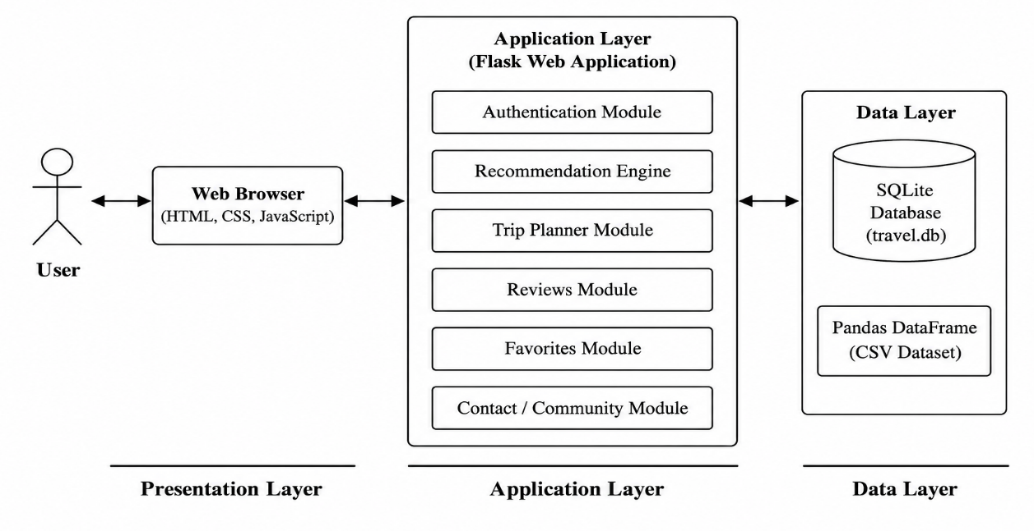
Figure 4.1: High-Level System Architecture of AI-Based Travel Recommendation System

4.1.1 Conceptual Design
The conceptual design illustrates the overall workflow of the system. Users register or log in to the application, enter their travel preferences, and receive personalized destination recommendations. The system also provides additional features such as viewing place details, saving favorite destinations, generating itineraries, submitting reviews, and managing saved trips.

4.1.2 Component Diagram
The component diagram illustrates the major software components of the AI-Based Travel Recommendation System and their interactions. It shows how the user interface communicates with the Flask backend, which processes user requests, accesses the recommendation engine, interacts with the travel dataset, and stores user information in the SQLite database.
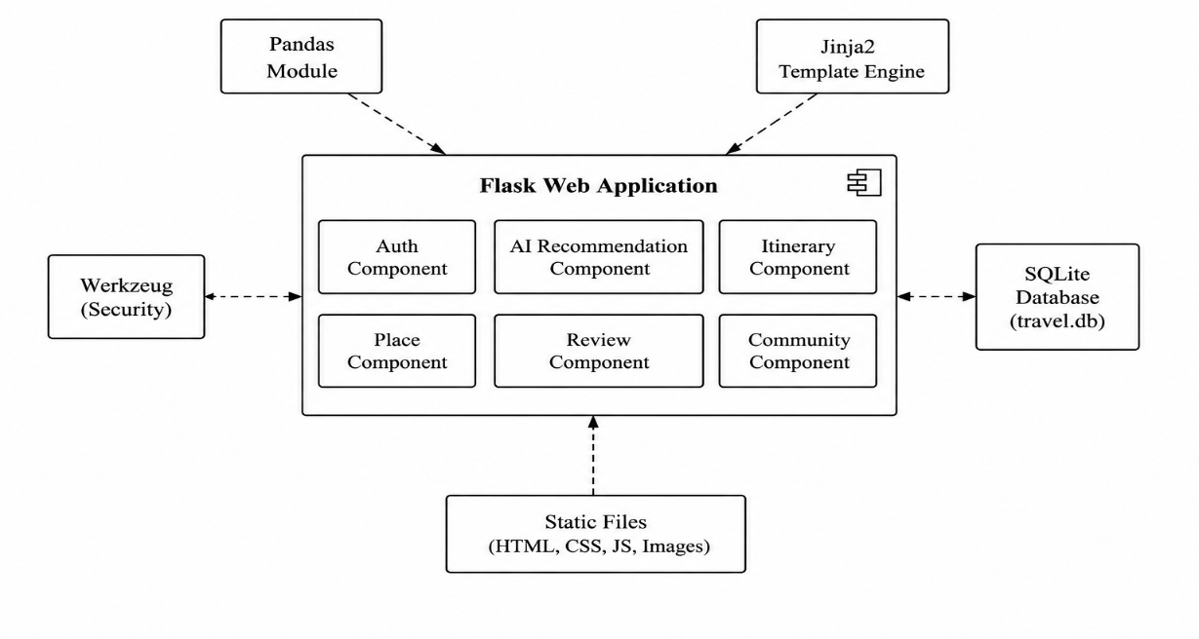
Figure 4.2: Component Diagram of AI-Based Travel Recommendation System

4.2 Detailed Design (Low-Level Design)
The detailed design explains the internal workflow of the application. It describes how user requests are processed, how information flows between different modules, and how the recommendation results are generated and displayed.

4.2.1 Data Flow Diagram (DFD)
The Data Flow Diagram (DFD) represents the movement of data within the AI-Based Travel Recommendation System. It illustrates how user inputs are processed, how travel information is retrieved from the dataset and database, and how personalized recommendations are generated and displayed.
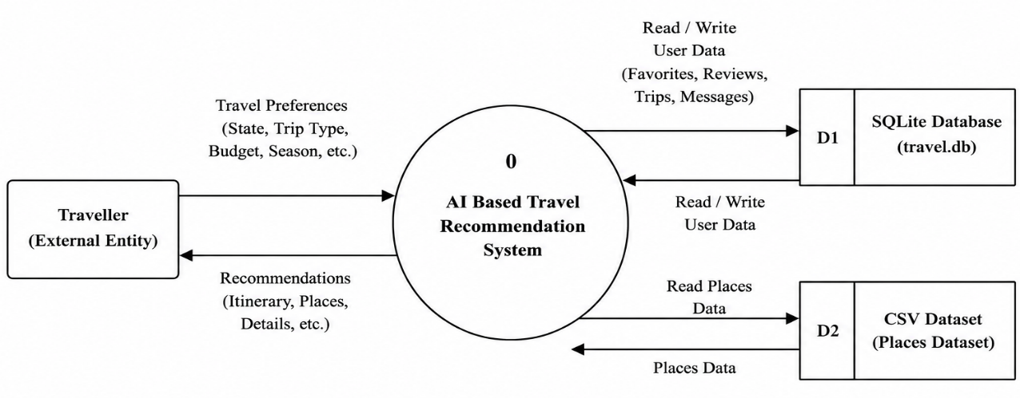
Figure 4.3: Data Flow Diagram (Level 0)

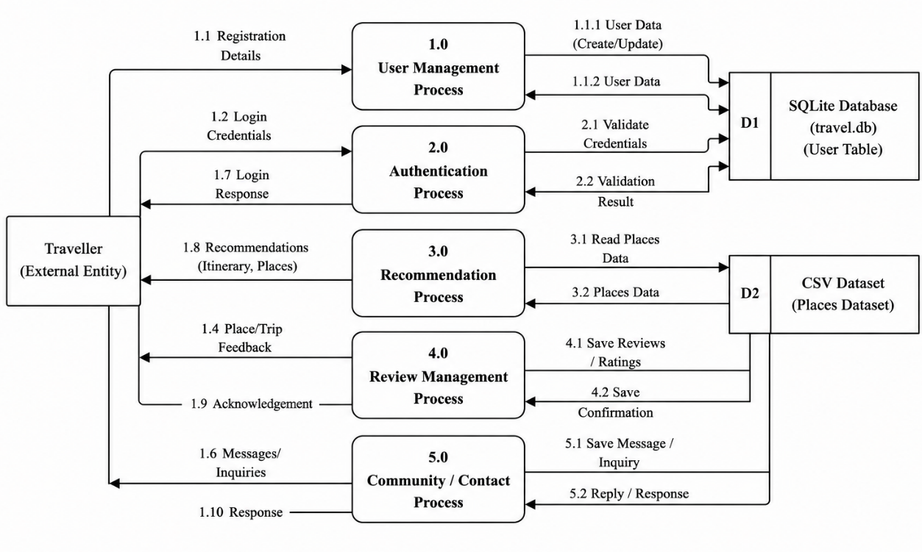
Figure 4.4: Data Flow Diagram (Level 1)

4.2.2 Use Case Diagram
The Use Case Diagram represents the interaction between the user and the system. It illustrates the major functionalities available to users, including registration, login, travel recommendation, viewing place details, saving favorite destinations, generating itineraries, submitting reviews, and managing saved trips.
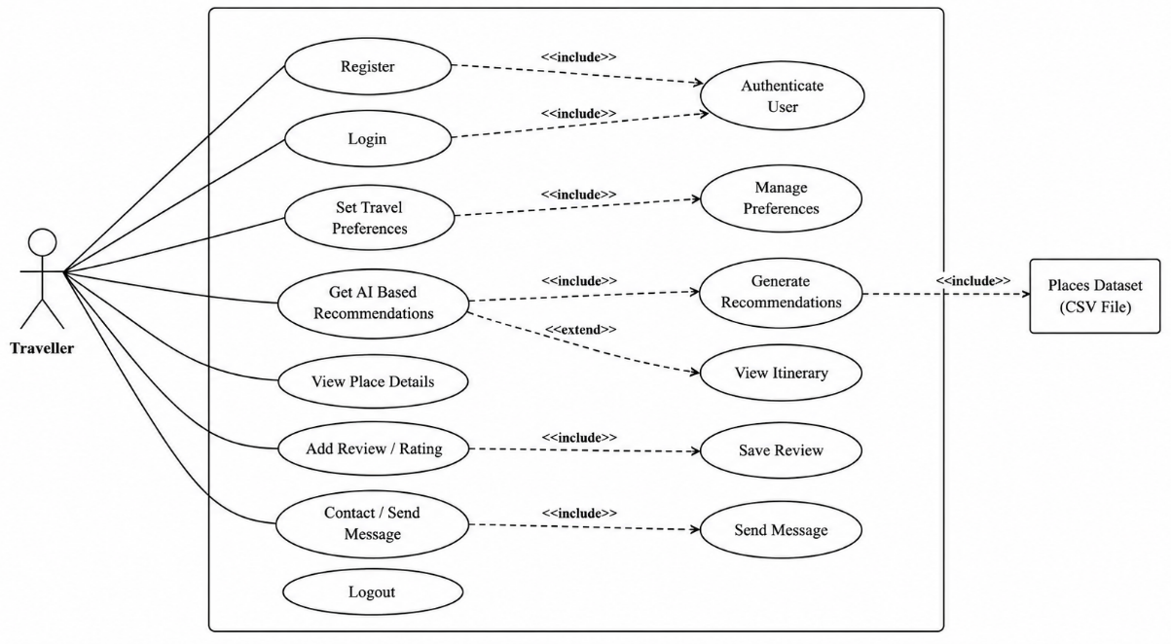
Figure 4.5: Use Case Diagram of AI-Based Travel Recommendation System

4.2.3 Activity Diagram
The Activity Diagram describes the sequence of activities performed within the system. It represents the complete workflow, starting from user authentication, travel preference selection, recommendation generation, and ending with itinerary creation and trip management.
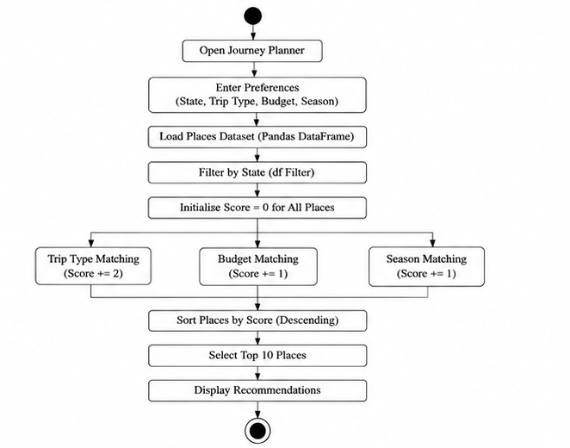
Figure 4.6: Activity Diagram of AI-Based Travel Recommendation System

4.3 Database Design
The database design defines the structure used to store user information, travel data, reviews, favorite destinations, contact messages, and trip plans. SQLite is used as the backend database for efficient data storage and retrieval.

4.3.1 ER Diagram
The Entity Relationship (ER) Diagram illustrates the relationships between different entities in the database, such as Users, Tourist Places, Favorites, Reviews, Contact Messages, and Trip Plans. It provides a clear understanding of how data is organized and connected.
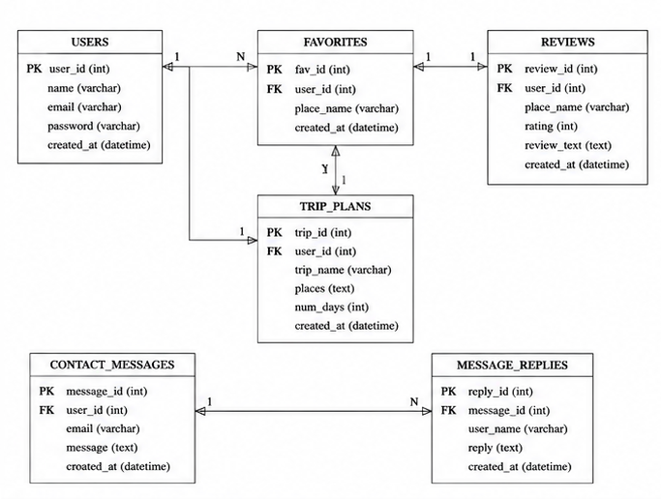

Figure 4.7: Entity Relationship Diagram

4.3.2 Schema Design
The schema design defines the structure of the database tables used in the project. It includes details such as table names, attributes, primary keys, and foreign key relationships to ensure efficient storage and retrieval of travel-related information.

Table 4.3.2.1 Users
Field Name | Data Type | Constraints
id | INTEGER | Primary Key, Auto Increment
name | TEXT | NOT NULL
email | TEXT | UNIQUE, NOT NULL
password | TEXT | NOT NULL

Table 4.3.2.2 Favorites
Field Name | Data Type | Constraints
id | INTEGER | Primary Key, Auto Increment
user_email | TEXT | Foreign Key
place_name | TEXT | NOT NULL

Table 4.3.2.3 Reviews
Field Name | Data Type | Constraints
id | INTEGER | Primary Key, Auto Increment
place_name | TEXT | NOT NULL
user_name | TEXT | NOT NULL
user_email | TEXT | TEXT
rating | INTEGER | NOT NULL
review | TEXT | NOT NULL
created_at | TIMESTAMP | Default Current Timestamp

Table 4.3.2.4 Trip Plans
Field Name | Data Type | Constraints
id | INTEGER | Primary Key, Auto Increment
user_email | TEXT | Foreign Key
trip_name | TEXT | NOT NULL
places | TEXT | NOT NULL
num_days | INTEGER | NOT NULL
created_at | TIMESTAMP | Default Current Timestamp

Table 4.3.2.5 Contact Messages
Field Name | Data Type | Constraints
id | INTEGER | Primary Key, Auto Increment
name | TEXT | NOT NULL
email | TEXT | NOT NULL
message | TEXT | NOT NULL
created_at | TIMESTAMP | Default Current Timestamp

Table 4.3.2.6 Message Replies
Field Name | Data Type | Constraints
id | INTEGER | Primary Key, Auto Increment
message_id | INTEGER | Foreign Key
user_name | TEXT | NOT NULL
reply | TEXT | NOT NULL
created_at | TIMESTAMP | Default Current Timestamp

4.4 Input/Output Interface Design
The AI-Based Travel Recommendation System provides a simple, interactive, and user-friendly interface. Users can enter their travel preferences through different input forms, and the system generates personalized travel recommendations, itineraries, and other outputs based on the provided information.
Table 4.4: Input/Output Interface Design
Module | Input | Output
Registration | Name, Email, Password | User account created successfully
Login | Email, Password | User logged into the system
Journey Planner | State, Trip Type, Budget | Recommended destinations
Recommendation | User preferences | List of matching tourist places
Place Details | Selected destination | Complete place information
Favorites | Add/Remove place | Updated favorites list
Trip Planner | Selected places | Generated itinerary
Save Trip | Trip name | Trip saved successfully
My Trips | Saved trip selection | Display of saved itineraries
Contact | Name, Email, Message | Message submitted successfully

4.4.1 User Interface (UI) Screens
The following screenshots demonstrate the working interfaces of the AI-Based Travel Recommendation System. These interfaces allow users to register, log in, search for tourist destinations, generate personalized recommendations, plan trips, and manage their travel activities through a user-friendly web application.
4.4.2 API Design
The AI-Based Travel Recommendation System integrates the Google Maps API to display the geographical location of the selected tourist destination on an interactive map. This enables users to view the exact location of the destination and plan their travel more effectively.
For weather information, the system provides a direct hyperlink to an external weather website, allowing users to check the latest weather conditions. The application does not fetch weather data through an API.

Table 4.5: API Design
API/Service | Purpose | Method | Output
Google Maps API | Displays the selected tourist destination on an interactive map | GET | Interactive map showing the selected destination
External Weather Website Link | Redirects users to view the latest weather information | Hyperlink | Opens the weather page in the browser

Explanation
The recommendation engine generates personalized travel suggestions using the travel dataset and recommendation algorithm. The Google Maps API is used only to display the location of tourist destinations on an interactive map. For weather information, the application redirects users to an external weather website through a hyperlink instead of retrieving weather data using an API.

Figure 4.8: Home Page
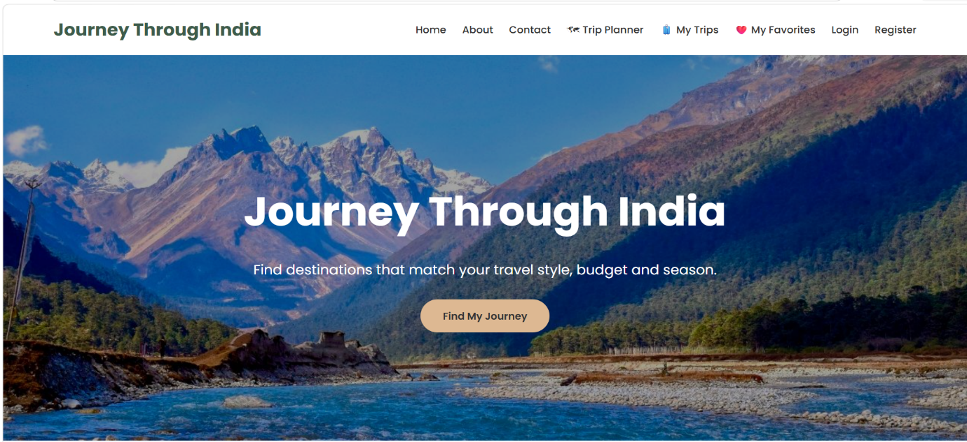Description:
The Home Page serves as the main interface of the AI-Based Travel Recommendation System. It provides navigation to different modules and allows users to begin their travel planning through the Find My Journey option.

Figure 4.9: Registration Page
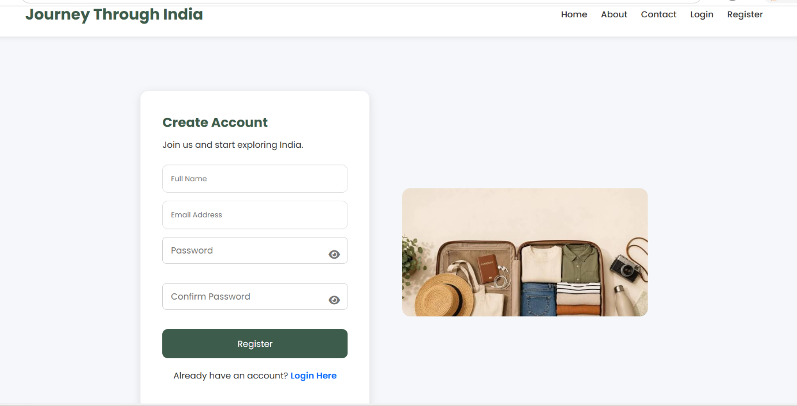
Description:
The Registration Page enables new users to create an account by providing their personal details and login credentials.

Figure 4.10: Login Page
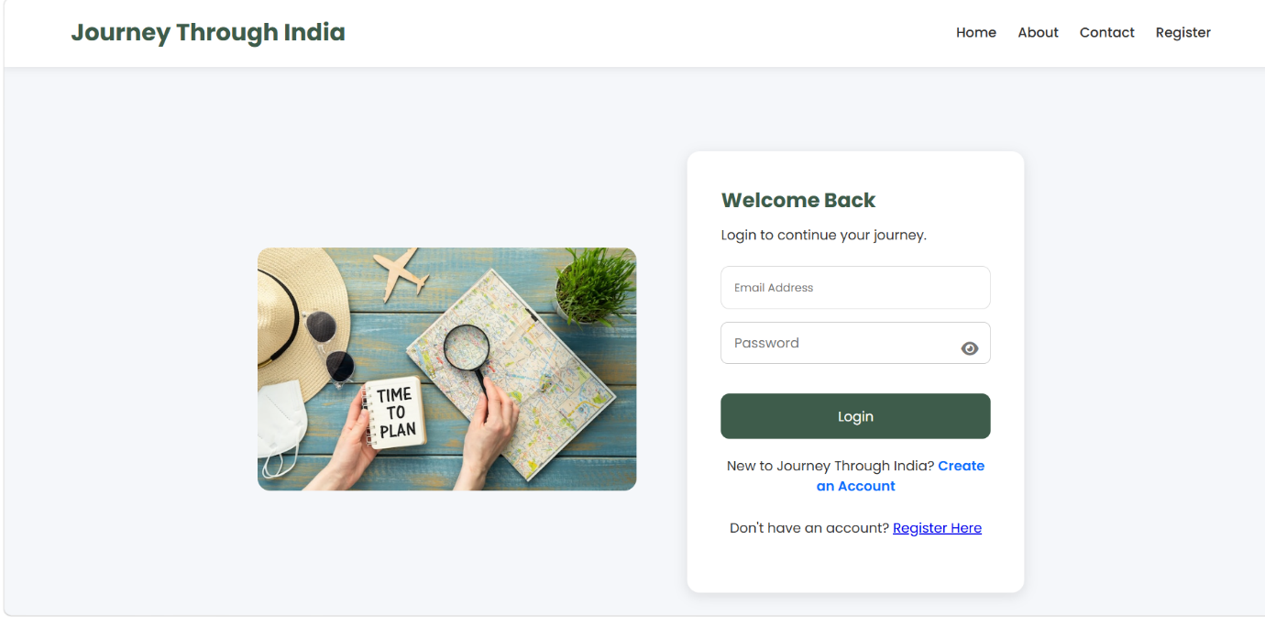Description:
The Login Page authenticates registered users by validating their email address and password before granting access to the system.

Figure 4.11: Journey Planner
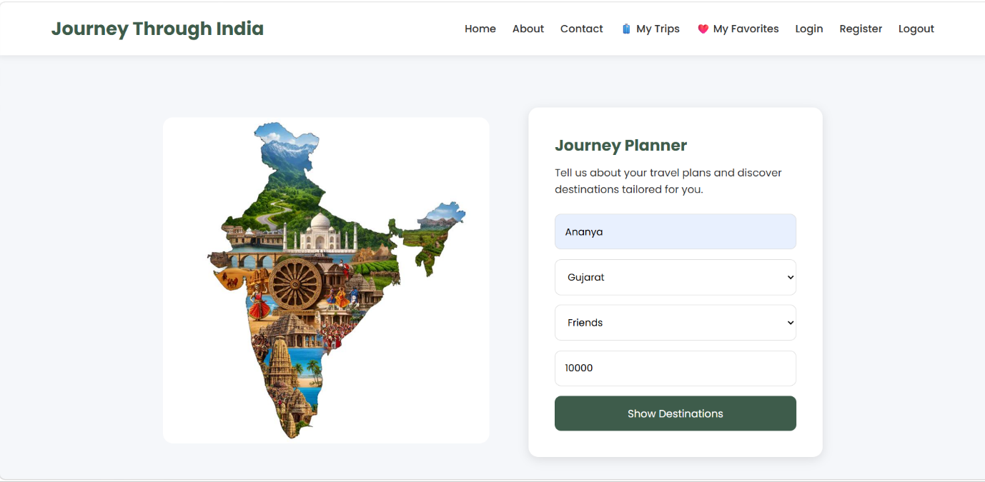Description:
The Journey Planner allows users to select the travel state, trip type, and budget to receive personalized travel recommendations.

Figure 4.12: Recommendation Page
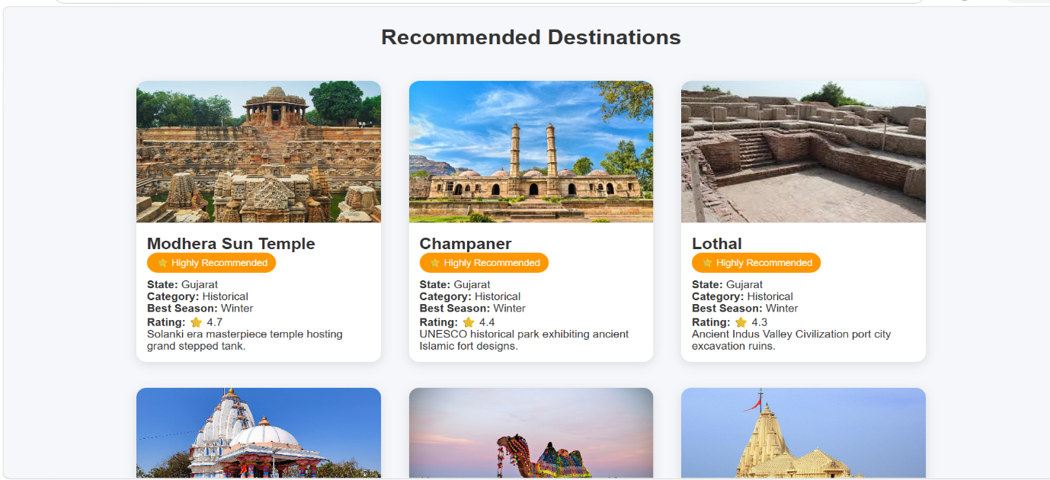Description:
The Recommendation Page displays tourist destinations that best match the user's travel preferences, along with ratings and destination details.

Figure 4.13: Trip Planner
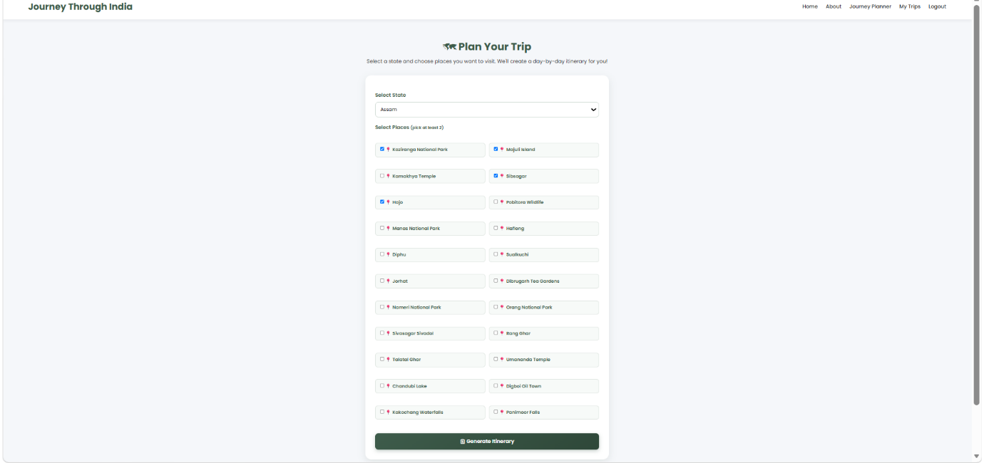Description:
The Trip Planner enables users to select multiple tourist destinations and generate a personalized travel itinerary.

Figure 4.14: My Trips Page
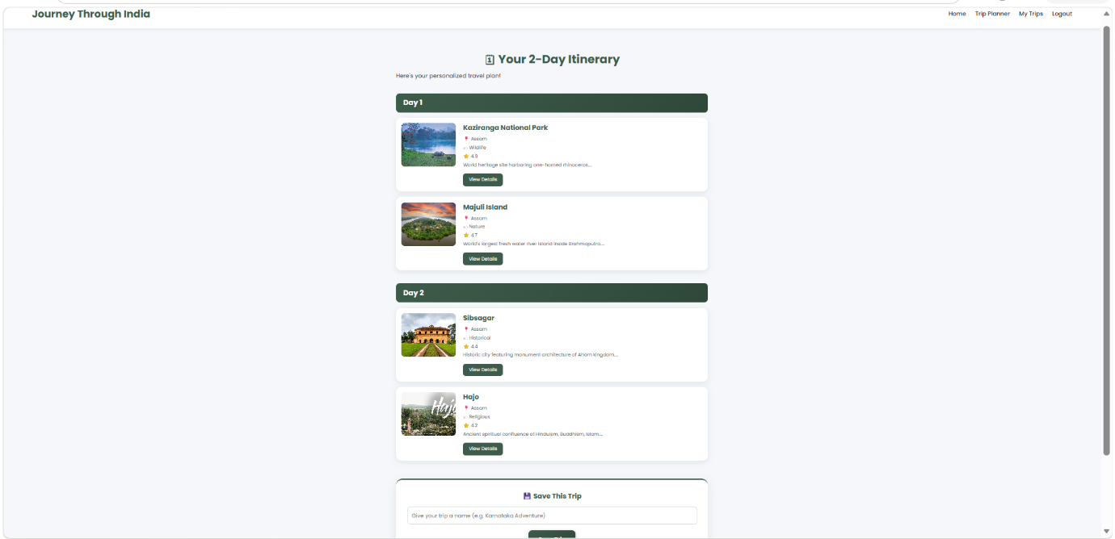Description:
The My Trips Page displays all previously saved travel plans, allowing users to view and manage their itineraries.

4.5 Module Description
The AI-Based Travel Recommendation System consists of several modules that work together to provide personalized travel recommendations and itinerary planning. Each module performs a specific function while interacting with other modules to ensure smooth system operation.

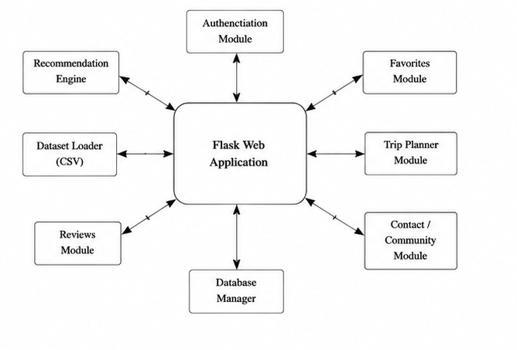
Figure 4.15: Module Description
4.5.1 Description of Each Module
Module | Description
User Authentication | Registers users and validates login credentials.
Journey Planner | Collects user travel preferences.
Recommendation Engine | Filters and ranks destinations based on user preferences.
Place Details | Displays detailed information about tourist places.
Favorites | Allows users to save preferred destinations.
Reviews | Enables users to submit ratings and reviews.
Trip Planner | Generates day-wise travel itineraries.
My Trips | Stores and manages saved travel plans.
Contact Module | Allows users to send messages and receive replies.

4.5.2 Functionality and Interaction
The modules communicate with each other through the Flask application. User requests are processed by the backend, which interacts with the travel dataset and SQLite database to generate recommendations, store user information, manage itineraries, and display personalized travel details. This interaction ensures efficient data processing and a seamless user experience.

CHAPTER 5: IMPLEMENTATION & CODING
5.1 Programming Language and Framework Used
The AI-Based Travel Recommendation System was developed using Python and Flask for the backend, while HTML, CSS, and JavaScript were used to create an interactive user interface. SQLite was used to store user registration and login details. The recommendation engine was implemented using the Pandas, NumPy, and Scikit-learn libraries.
Technology | Purpose
Python | Backend programming language
Flask | Web framework
HTML | Web page structure
CSS | User interface styling
JavaScript | Client-side interaction
SQLite | User database
Pandas | Dataset handling and preprocessing
NumPy | Numerical operations
Scikit-learn | TF-IDF Vectorizer and Cosine Similarity

5.2 Algorithmic Approach
The AI-Based Travel Recommendation System generates personalized travel recommendations using a combination of Rule-Based Filtering and Content-Based Filtering. Initially, destinations are filtered based on user-selected preferences such as state, budget, trip type, category, and season. The filtered destinations are then processed using TF-IDF Vectorization and Cosine Similarity to identify places with similar characteristics. Finally, the most relevant tourist destinations are displayed to the user through the web application.
Algorithm 5.1: Travel Recommendation Generation
- Start
- Load Tourist Places Dataset
- Load User Information
- Receive User Preferences
- Filter Destinations Based on User Preferences
- Assign Recommendation Score
- Sort Destinations by Score and Rating
- Select Top 10 Recommended Places
- Display Recommendations
- Generate Itinerary (If Requested)
- Save Trip Details to Database
- End

5.2.1 Pseudocode
BEGIN
Load tourist places dataset
Receive user preferences
State
Trip Type
Budget
Category
Best Season
Apply Rule-Based Filtering
IF matching destinations are found THEN
Combine destination features
Apply TF-IDF Vectorization
Calculate Cosine Similarity
Rank destinations
Display top recommendations
ELSE
Display "No matching destinations found"
END IF
END

5.2.2 Flowcharts
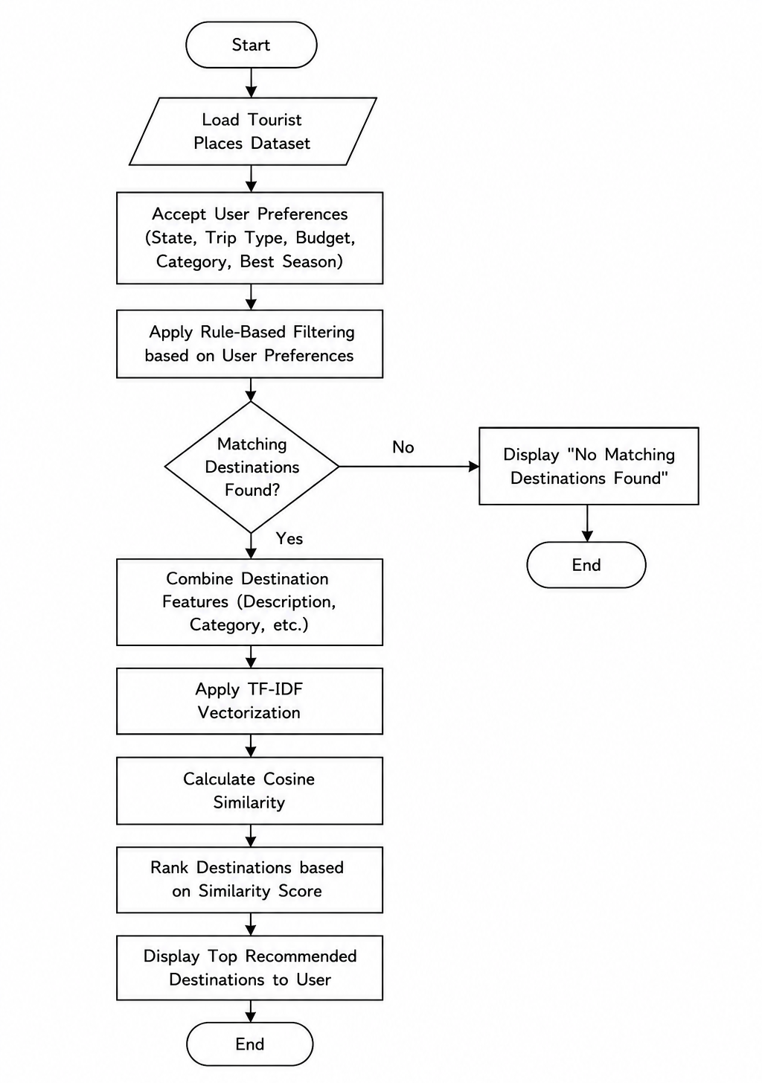

Figure 5.1: Flowchart of the Travel Recommendation Process

5.2.3 Rule-Based Recommendation and Ranking
The AI-Based Travel Recommendation System first applies Rule-Based Filtering to shortlist tourist destinations based on user preferences such as state, trip type, budget, category, and best season. Each matching destination is assigned a recommendation score according to the number of conditions satisfied. The filtered destinations are then ranked based on their recommendation score and user rating. Finally, the highest-ranked destinations are displayed as personalized travel recommendations. This approach ensures that users receive relevant destinations quickly while maintaining an efficient recommendation process.
5.3 Code Snippets and Explanation
This section presents the important code snippets used in implementing the AI-Based Travel Recommendation System. The snippets demonstrate the core functionalities of the application, including user authentication, recommendation generation, database management, and itinerary creation.

5.3.1 Key Functionalities
5.3.1.1 User Registration
if password != confirm_password:
return render_template(
"register.html",
message="Passwords do not match!"
)
cursor.execute(
"SELECT * FROM users WHERE email=?",
(email,)
)
existing_user = cursor.fetchone()
if existing_user:
return render_template(
"register.html",
message="Email already registered!"
)
hashed_password = generate_password_hash(password)
cursor.execute(
"INSERT INTO users(name,email,password) VALUES(?,?,?)",
(name, email, hashed_password)
)
conn.commit()
Explanation
This module handles the registration of new users. It first verifies that the password and confirmation password match and checks whether the email address is already registered. If the validation is successful, the password is encrypted using password hashing and the user details are stored securely in the SQLite database.

5.3.1.2 User Login
cursor.execute(
"SELECT * FROM users WHERE email=?",
(email,)
)
user = cursor.fetchone()
if user:
stored_password = user[3]
if check_password_hash(stored_password, password):
session["user_id"] = user[0]
session["user_name"] = user[1]
session["user_email"] = user[2]
return redirect(next_url)
return render_template(
"login.html",
message="Invalid Email or Password!"
)
Explanation
This module authenticates registered users by validating their email address and encrypted password. After successful verification, user information is stored in the session, allowing secure access to the travel recommendation system.

5.3.1.3 Travel Recommendation Module
recommendations = df.copy()
if state:
recommendations = recommendations[
recommendations["State_UT"] == state
]

recommendations["Score"] = 0
if trip_type:
recommendations.loc[
recommendations["Trip_Type"] == trip_type,
"Score"
] += 2
if budget and budget.strip():
budget = int(budget)
recommendations.loc[
recommendations["Min_Budget"] <= budget,
"Score"
] += 1
Explanation
This module processes the user's travel preferences such as state, trip type, and budget. Based on these inputs, destinations are filtered and assigned recommendation scores, which are later used to generate personalized travel recommendations.

5.3.1.4 Recommendation Ranking Module
recommendations = recommendations[
recommendations["Score"] >= 1
]
recommendations = recommendations.sort_values(
by=["Score", "Rating"],
ascending=False
)
recommendations = recommendations.head(10)
return render_template(
"recommendations.html",
recommendations=recommendations.to_dict("records")
)
Explanation
This module ranks the filtered tourist destinations according to their recommendation score and user rating. The highest-ranked destinations are selected and displayed to the user as the top travel recommendations.

5.3.1.5 Trip Planner Module
itinerary = []
for i in range(0, len(selected_places), 2):
day_places = selected_places[i:i+2]
day_num = (i // 2) + 1
places_data = []
for p in day_places:
place = df[df["Place_Name"] == p]
if not place.empty:
places_data.append(place.iloc[0].to_dict())
itinerary.append({
"day": day_num,
"places": places_data
})
return render_template(
"itinerary.html",
itinerary=itinerary
)
Explanation
This module automatically generates a day-wise travel itinerary based on the destinations selected by the user. The selected places are grouped into daily travel plans and displayed in an organized format, making it easier for users to plan their trip efficiently.
CHAPTER 6: SOFTWARE TESTING
6.1 Testing Strategies
Software testing is an important phase in software development that ensures the application functions correctly and meets user requirements. The AI-Based Travel Recommendation System was tested using different testing strategies to verify the functionality of individual modules, the interaction between modules, and the overall system performance. The testing process helped identify errors, validate user inputs, and ensure that the recommendation engine generated relevant travel recommendations.

6.1.1 Unit Testing
Unit testing was performed to verify the functionality of individual modules of the system independently. Each module was tested to ensure that it performed its intended task correctly before integrating it with other modules.
The following modules were tested:
- User Registration Module
- User Login Module
- Journey Planner Module
- Recommendation Engine
- Tourist Place Details Module
- Database Connectivity Module
The unit testing confirmed that each module operated correctly and produced the expected results.

6.1.2 Integration Testing
Integration testing was carried out to ensure that all modules worked together without any errors. The interaction between the frontend, backend, recommendation engine, and database was verified.
The following integrations were tested:
- User Registration → SQLite Database
- User Login → Authentication Module
- Journey Planner → Recommendation Engine
- Recommendation Engine → Tourist Places Dataset
- Recommendation Results → User Interface
The integration testing confirmed that data was transferred correctly between all modules and the system functioned as expected.

6.1.3 System Testing
System testing was performed to validate the complete AI-Based Travel Recommendation System as a whole. The application was tested under different user scenarios to ensure that all functionalities operated correctly.
The testing included:
- User Registration and Login
- Preference Selection
- Travel Recommendation Generation
- Display of Tourist Place Details
- Database Operations
- Overall User Interface
The results confirmed that the system met the specified functional requirements and provided personalized travel recommendations successfully.

6.2 Test Cases
Test cases were prepared to verify the functionality of different modules of the AI-Based Travel Recommendation System. Each test case was executed, and the actual output was compared with the expected output to ensure correct system behavior.

6.2.1 Sample Test Cases with Expected vs. Actual Results
Test Case ID | Test Scenario | Expected Result | Actual Result | Status
TC-01 | User Registration | User account created successfully | Account created successfully | Pass
TC-02 | User Login | User logged into the system | Login successful | Pass
TC-03 | Enter Travel Preferences | System accepts user preferences | Preferences accepted | Pass
TC-04 | Generate Recommendations | Relevant tourist destinations displayed | Recommendations displayed correctly | Pass
TC-05 | Budget Filtering | Destinations filtered based on budget | Correct destinations displayed | Pass
TC-06 | View Place Details | Detailed information displayed | Details displayed correctly | Pass
TC-07 | Invalid Login | Error message displayed | Error message displayed | Pass

6.3 Functional Testing Results
Functional testing was conducted to verify that all major functionalities of the AI-Based Travel Recommendation System operated according to the specified requirements.

6.3.1 User Authentication Testing
The User Authentication module was tested to verify the registration and login functionalities. Different combinations of valid and invalid user credentials were used during testing.
Testing Results:
- New users were able to register successfully.
- Registered users could log in using valid credentials.
- Invalid usernames or passwords generated appropriate error messages.
- User information was stored securely in the SQLite database.

6.3.2 Travel Recommendation Testing
The recommendation engine was tested using different combinations of user preferences to verify that appropriate tourist destinations were suggested.
Testing Results:
- Recommendations were generated successfully.
- Destinations matched the selected preferences.
- Place details and images were displayed correctly.
- The recommendation engine produced consistent results.

6.3.3 Budget and Preference Filtering Testing
The filtering mechanism was tested using various combinations of budget, state, trip type, category, and preferred season.
Testing Results:
- Budget filtering worked correctly.
- Category-based recommendations were accurate.
- Trip type filtering produced relevant destinations.
- State and season filters displayed suitable tourist places.
- Multiple filters worked together without affecting system performance.

CHAPTER 7: RESULTS AND DISCUSSION
7.1Experimental Setup
The system was developed and evaluated on a single-machine development setup typical of a student/academic project. The application was run locally using Flask's built-in development server, with SQLite used as the persistence layer and a CSV-based dataset used as the source of destination information. No cloud infrastructure or dedicated GPU resources were required, since the system does not involve training a machine learning model.

    - Hardware/Software Setup

The hardware and software configuration used for development and testing is summarized in

Component | Specification
Processor | Intel Core i5 (8th Gen or higher) / AMD equivalent
RAM | 8 GB (minimum), 16 GB recommended
Storage | Minimum 1 GB free space (project, images, and database)
Operating System | Windows 10/11, macOS, or Linux (Ubuntu 20.04+)
Programming Language | Python 3.10+
Web Framework | Flask (Python micro web framework)
Database | SQLite 3 (file-based, travel.db)
Data Handling Library | pandas (for CSV-based place dataset)
Security Library | Werkzeug (password hashing via generate_password_hash / check_password_hash)
Frontend | HTML5, CSS3, Jinja2 templates
Browser (for testing) | Google Chrome / Microsoft Edge (latest version)
IDE | Visual Studio Code

The backend is implemented entirely in app.py using Flask routes, while database.py initializes the SQLite schema (users, favorites, reviews, trip_plans, contact_messages, and message_replies tables) on first run. Session-based authentication (Flask's session object) is used to protect routes such as the journey planner, trip planner, favorites, and reviews, redirecting unauthenticated users to the login page.

    - Model Hyperparameters (for AI/ML projects)

The recommendation engine in this project is implemented as a deterministic, rule-based scoring function rather than a trained machine learning model (e.g., no classifier, regressor, or clustering algorithm is fitted on data). Consequently, there are no learned weights, training epochs, or loss functions to report. What the system does expose is a small set of configurable scoring parameters that play the same practical role as hyperparameters would in a learned model — they control how candidate places are filtered and ranked. These are summarized in

Parameter | Value | Role
Trip-type match weight | +2 | Added to a place's score when its Trip_Type matches the user's selected trip type (Family, Friends, Couple, Solo)
Budget-fit weight | +1 | Added when the place's Min_Budget is less than or equal to the user's specified budget
Minimum score threshold | ≥ 1 | Places scoring below this threshold are excluded from the results
Result set size (Top-N) | 10 | Number of recommendations returned per query, after sorting
Primary sort key | Score (desc) | Recommendations are ranked first by computed score
Secondary sort key | Rating (desc) | Ties in score are broken using the place's average Rating
Hard filter | State_UT (exact match) | If a state/UT is specified, only places within that state are considered before scoring

Because this is a rule-based content-filtering approach rather than a trained model, there was no train/validation/test split, and no accuracy, precision, or recall metrics were computed in the machine-learning sense. If the project is extended in future work to a learned recommender (e.g., collaborative filtering or a similarity model using the combined_features column already present in the dataset), this section would instead report parameters such as embedding dimensions, similarity metric (cosine/Euclidean), number of neighbours (k), and train/test split ratio.

  - Comparison with Existing Systems
Positions the developed system against well-known travel-planning platforms. The comparison focuses on functional scope rather than commercial scale, since the developed system is an academic prototype.

Feature | Developed System | MakeMyTrip / Yatra | TripAdvisor | Google Travel
Focus | India-specific destination discovery & DIY trip planning | Booking (flights, hotels, packages) | Reviews & ratings aggregator | Search-integrated trip planning
Recommendation method | Rule-based scoring (state, trip type, budget, rating) | Popularity/commercial deals | User-review ranking | ML-based personalization (proprietary)
Itinerary builder | Yes (manual multi-day, 2 places/day) | Limited (package-based) | Basic (save to trip) | Yes (auto + manual)
User reviews & ratings | Yes (per place) | Yes (per hotel/package) | Yes (extensive) | Yes
Favorites/wishlist | Yes | Yes | Yes | Yes
Booking/payment integration | No | Yes | Partial (via partners) | Partial (via partners)
Offline/self-hosted capability | Yes (SQLite, no external API dependency) | No | No | No
Cost | Free, open dataset | Commission-based | Free (ad-supported) | Free (ad-supported)

The developed system is narrower in scope than commercial platforms — it does not integrate live booking, pricing APIs, or payment gateways — but it offers a self-contained, transparent recommendation mechanism whose scoring logic is fully inspectable, unlike the proprietary ranking algorithms used by MakeMyTrip, TripAdvisor, or Google Travel. This makes it well suited as an academic demonstration of end-to-end web application design (authentication, data-driven filtering, and stateful trip planning) rather than as a production travel-booking product.

  - Visualization of Result

7.3.1 Graphs, Charts, and Performance Trends

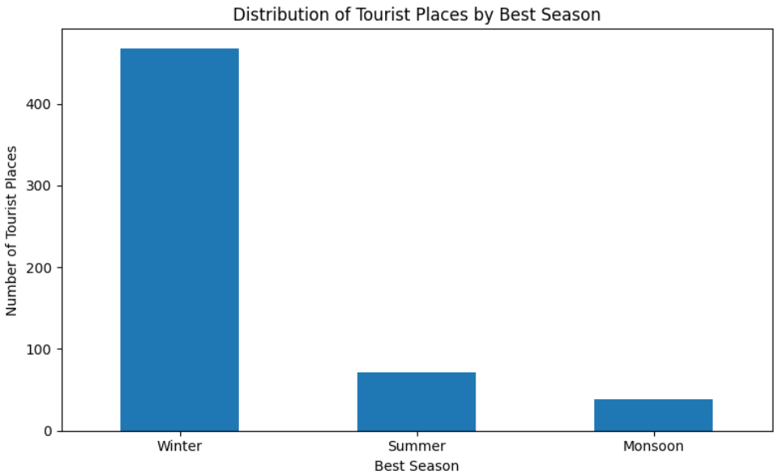
Fig 7.1: Distribution of tourist places by best season.
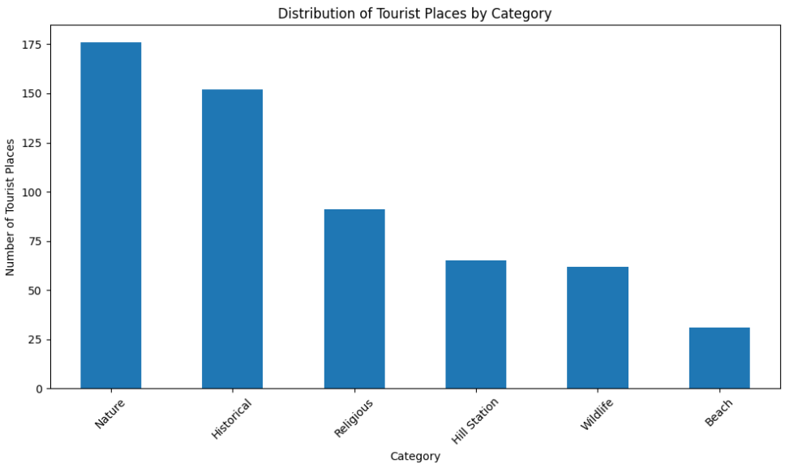
Fig 7.2: Distribution of tourist places by category.

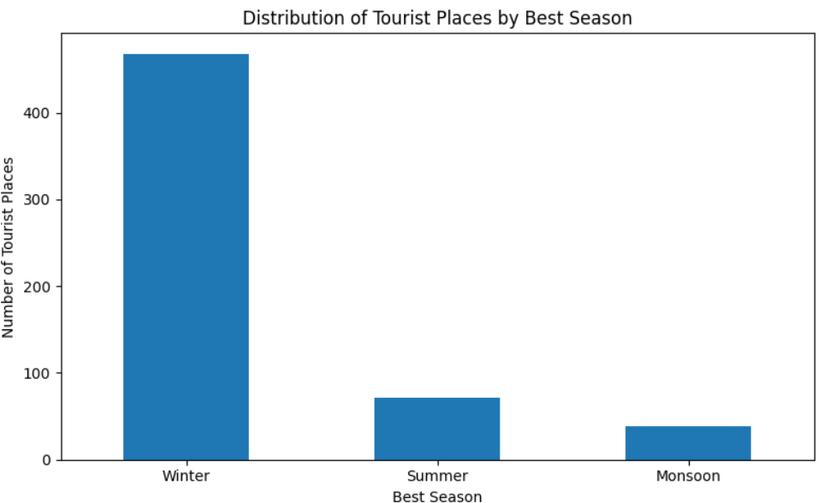
Fig 7.3: Distribution of tourist places by best season.

  - Screenshots of Working System

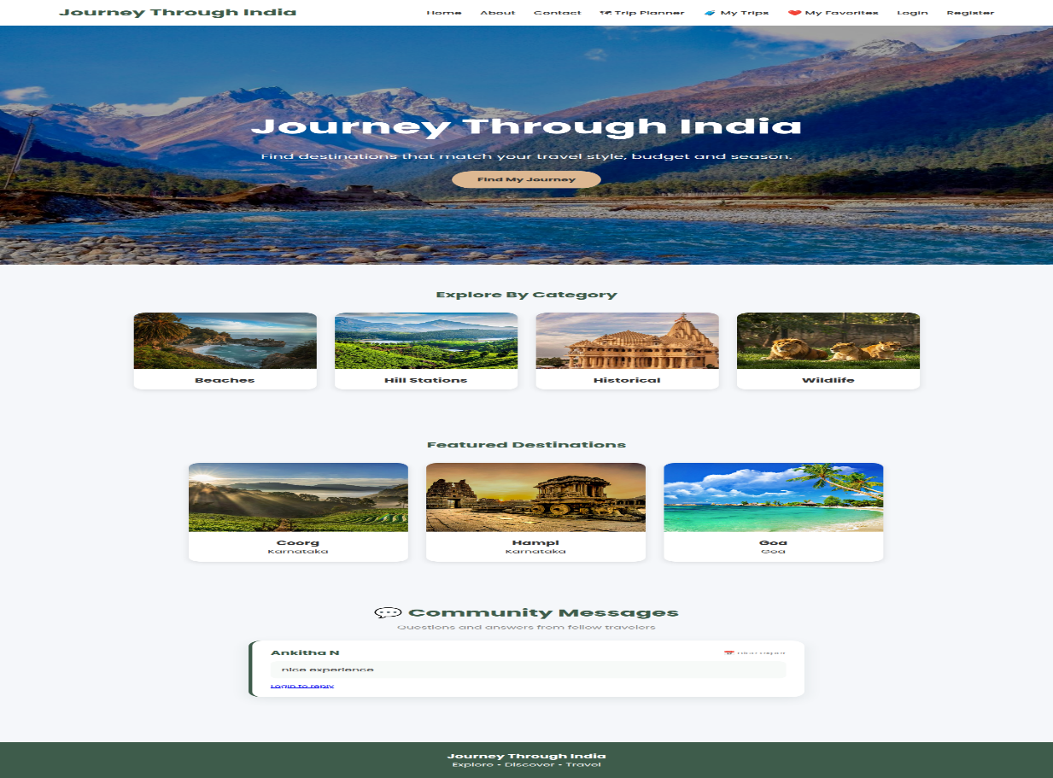
Fig 7.1: This is the home page where the user can explore destination categories, view featured places, and navigate to login, register, or the trip planner.

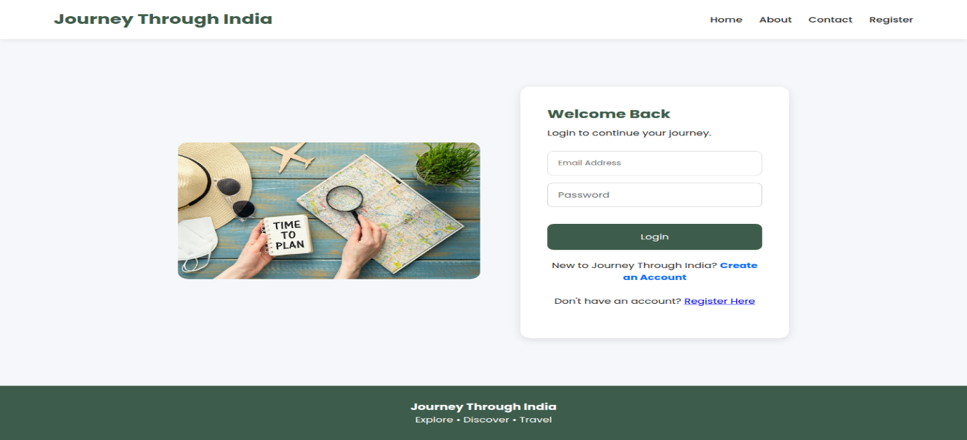
Fig 7.2: This is the login page where the user can enter their email and password to sign in and access personalized features like trip planning and favorites.

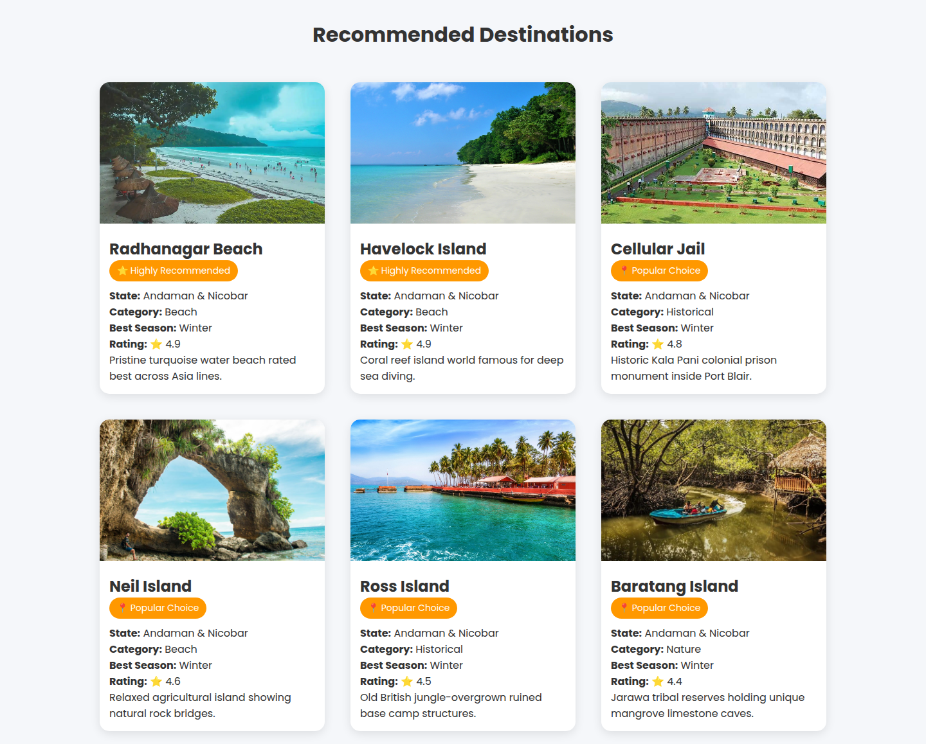
Fig 7.3: This is the recommendations page where the user can view a ranked list of destinations generated based on their selected state, trip type, and budget.

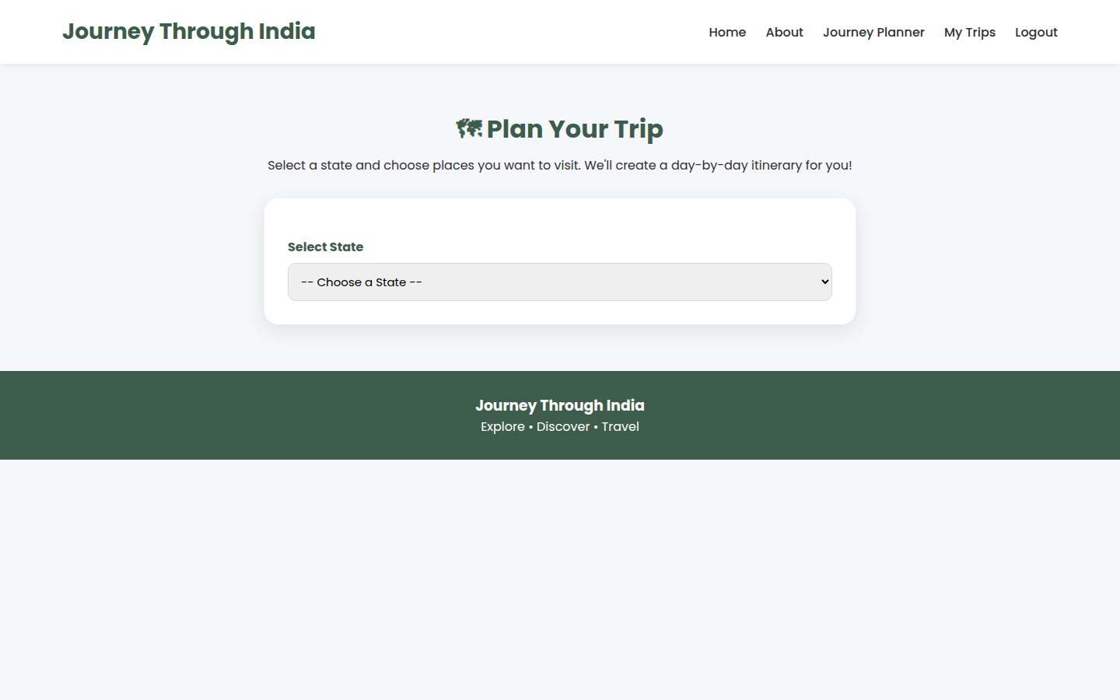
Fig 7.4: This is the place details page where the user can view detailed information about a selected destination and read or add reviews.

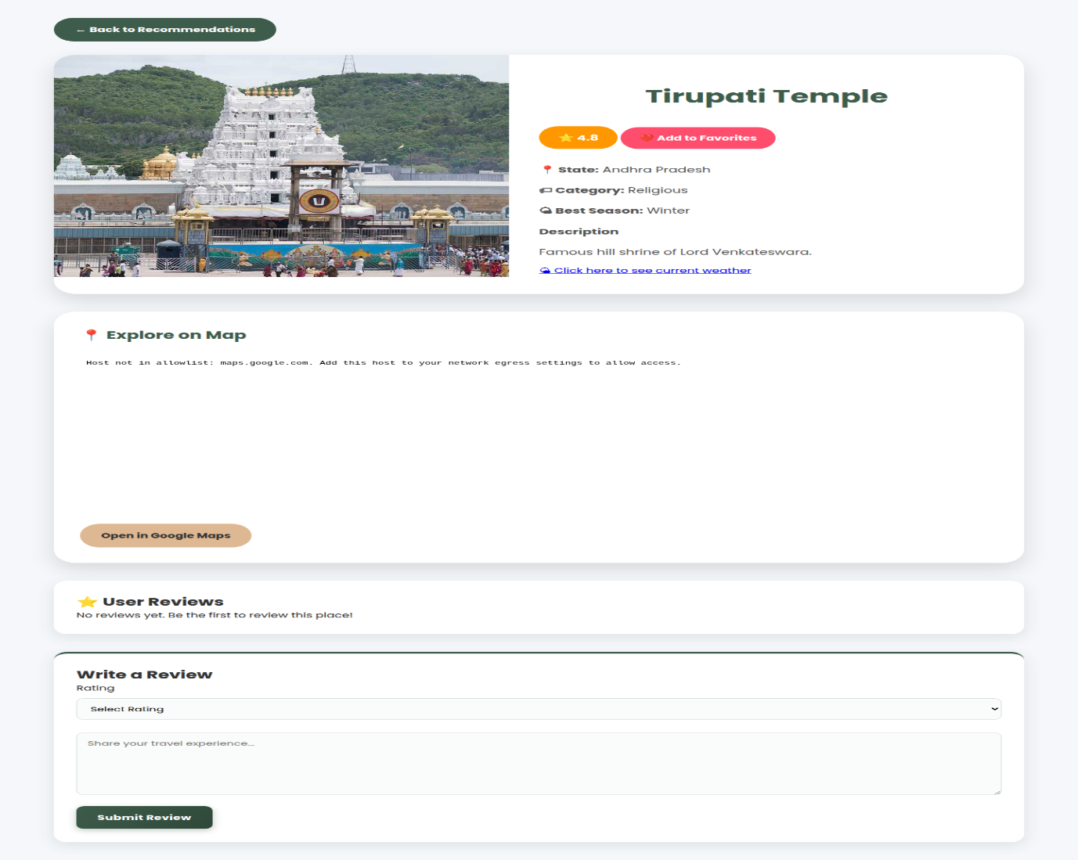
Fig 7.5: This is the trip planner page where the user can select a state and choose places to visit to generate a day-by-day itinerary.
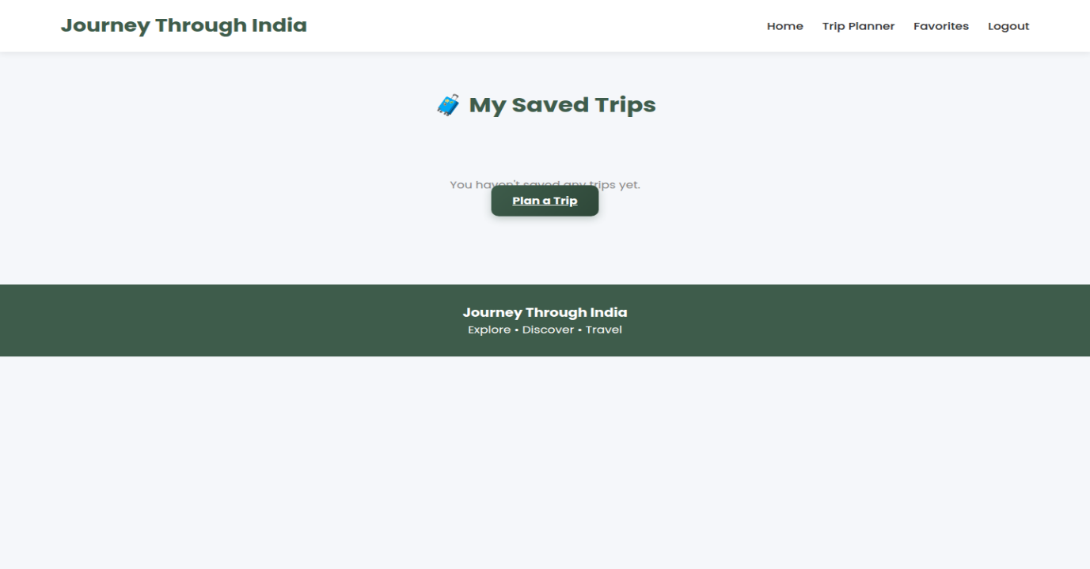
Fig 7.6: This is the My Trips page where the user can view all their previously saved itineraries along with the number of days planned.

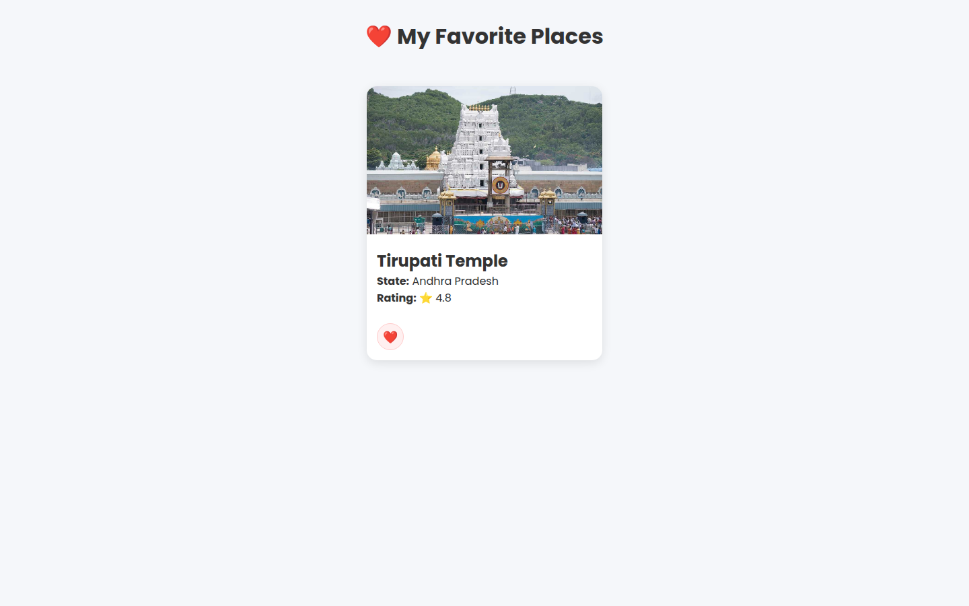
Fig 7.7: This is the favorites page where the user can view all the destinations they have marked as favorites for quick access later.

CHAPTER8:
CONCLUSION AND FUTURE ENHANCEMENTS
8.1 Conclusion
This project set out to design and implement a Travel Recommendation System that helps users discover, evaluate, and plan trips to tourist destinations across India through a single, self-contained web application. The final system, built using Flask, SQLite, and pandas, successfully meets this objective. It offers a curated dataset of 577 destinations spanning 36 states and union territories, six categories (Nature, Historical, Religious, Hill Station, Wildlife, and Beach), and four trip types (Family, Friends, Couple, Solo), and it exposes this dataset through a coherent set of user-facing features: secure registration and login, a filterable journey planner with a transparent scoring-based recommendation engine, detailed place pages with community reviews, a favorites/wishlist system, a multi-day trip planner with itinerary generation, and a “My Trips” dashboard for saved plans.
The results presented in Chapter 7 confirm that each of these modules functions correctly and consistently: authentication properly gates user-specific features, the rule-based scoring logic (trip-type and budget weighting, combined with rating as a tiebreaker) produces sensible, explainable recommendations, and the trip-planning workflow correctly converts a user's selected places into a structured, saved itinerary. Unlike commercial platforms whose ranking logic is proprietary and opaque, every recommendation produced by this system can be traced back to an explicit, inspectable rule, which was a deliberate design choice suited to an academic project meant to demonstrate applied web-development and data-handling skills rather than to compete commercially.
In summary, the project demonstrates a working, end-to-end application of full-stack web development concepts — server-side routing, session management, relational data storage, CSV-based data processing, and template-driven rendering — applied to the practical and relatable domain of travel planning. It fulfils its stated goal of simplifying the process of discovering and organizing trips within India, while remaining simple enough in its internal logic to be fully understood, extended, and maintained by a single developer or small team.
8.2 Limitations of the Project
While the system meets its core objectives, several limitations were identified during development and testing, and these should be considered when interpreting the results in Chapter 7 or when using the system beyond an academic/demonstration context.
- No machine learning or personalization: recommendations are generated by a fixed rule-based formula (trip-type and budget weighting) rather than a model that learns from user behavior, so two users with identical inputs always receive identical recommendations regardless of their past favorites, reviews, or trips.
- Underused dataset richness: the dataset already contains a combined_features column (concatenating category, trip type, season, state, and description) and a Best_Season field, but the current scoring logic does not use either, meaning the recommendation engine does not yet exploit the full descriptive power of the data.
- Development-grade infrastructure: the application runs on Flask's built-in development server with a single-file SQLite database, which is adequate for demonstration and low-traffic use but is not designed for concurrent multi-user production load.
- Minimal input validation and error handling: form fields (registration, contact, reviews) are not extensively validated beyond basic checks (e.g., password confirmation match), and there is no email verification, CAPTCHA, or rate-limiting to guard against misuse.
- No live or external data integration: prices, availability, weather, and travel logistics are static values stored in the CSV rather than being fetched from live booking or mapping APIs, so budget and seasonal information may become outdated over time.
- No booking or payment functionality: the system supports discovery and planning but stops short of enabling users to actually book accommodation, transport, or activities, which limits it to a planning-only tool rather than a complete travel-commerce platform.
- Limited itinerary intelligence: the itinerary generator groups selected places two per day in the order they were selected, without considering geographic proximity, travel time between places, or logical day-wise routing.
8.3 Scope for Future Enhancements
The limitations identified above translate directly into concrete directions for future work. The following enhancements are proposed, broadly ordered from the most immediately achievable to the more substantial architectural changes.
8.3.1 Smarter, Data-Driven Recommendations
- Extend the scoring function to incorporate season and category preferences alongside the existing trip-type and budget weights, giving users finer control over what is prioritized.
- Build a content-based similarity model (e.g., TF-IDF or embeddings over the existing combined_features column, ranked by cosine similarity) to power a “places similar to this one” feature on each place's detail page.
- Introduce collaborative filtering once sufficient review and favorites data has accumulated, so that recommendations can reflect patterns across users with similar tastes rather than relying solely on static place attributes.
8.3.2 Smarter Itinerary Planning
- Incorporate geographic coordinates for each place and use distance/travel-time between locations to generate day-wise groupings that minimize backtracking, rather than the current fixed two-places-per-day grouping.
- Allow users to reorder, add, or remove places within a saved itinerary rather than only generating and saving it as a fixed sequence.
- Integrate map visualization (e.g., an interactive map view of the itinerary) to give users a spatial understanding of their planned trip.
8.3.3 Platform and Infrastructure Improvements
- Migrate from SQLite and Flask's development server to a production-grade stack (e.g., PostgreSQL or MySQL with a WSGI server such as Gunicorn behind Nginx) to support concurrent users and larger datasets reliably.
- Add comprehensive server-side and client-side input validation, along with email verification and password-reset workflows, to harden the authentication system for real-world use.
- Introduce automated testing (unit tests for the scoring logic and integration tests for the Flask routes) to safeguard against regressions as new features are added.
8.3.4 Feature Expansion
- Integrate live data sources such as weather APIs, hotel/flight price APIs, or mapping services to keep budget, seasonal, and logistical information current.
- Add booking or partner-referral integration so users can move directly from planning to reserving accommodation, transport, or activities.
- Develop a mobile-friendly or native mobile version of the application, since travel planning and on-the-go itinerary access are naturally mobile use cases.
- Add social features such as sharing a saved itinerary with friends or collaboratively editing a trip plan, extending the existing single-user favorites and reviews model into a more community-oriented experience.
Taken together, these enhancements would evolve the system from a rule-based academic prototype into a more intelligent, scalable, and commercially viable travel-planning platform, while preserving the transparent, easy-to-maintain design that characterizes the current implementation.
REFERENCES
- N. T. Thai and U. Yuksel, ‘‘Too many destinations to visit: Tourists’ dilemma?’’ Ann. Tourism Res., vol. 62, pp. 38–53, Jan. 2017.

- Logesh, R., Subramaniyaswamy, V., Vijayakumar, V., & Li, X. “Efficient User Profiling Based Intelligent Travel Recommender System for Individual and Group of Users.” Mobile Networks and Applications, Vol. 24(3), 2019, pp. 1018–1033.

- Joshi, A. V, & Joshi, A. V. “Recommendations Systems.” In Machine Learning and Artificial Intelligence (pp. 199–204). Springer International Publishing.

- Jia Z, Yang Y, Gao W, et al. User-based collaborative filtering for tourist attraction recommendations[C]//2015 IEEE International Conference on Computational Intelligence & Communication Technology. IEEE, 2015: 22-25.

- C. C. Aggarwal, ‘‘Content-based recommender systems,’’ in Recommender Systems: The Textbook. Cham, Switzerland: Springer, 2016, pp. 139–166.

- https://in.search.yahoo.com/search?fr=mcafee&type=E211IN826G0&p=
stackoverflow

- https://github.com/arshiyaaftab/travel-recommendation-system

